|  |  |  |  |  |
| --- | --- | --- | --- | --- |
|  | | | | |
| Simple, Decent, Affordable Houses Youth Educational Activity | | | | |
|  | | | | |
| ***Activity:***  Youth will build model Habitat houses. |  |  |  |  |
| ***Materials:***  One cereal box per student (preferably the larger sized box); markers; crayons; scotch tape; glue (preferably in  stick form); scissors; construction paper |
|  |  |
| ***Setup:***   * You may want to ask students to bring in their own |
| cereal boxes. Bring in several extra boxes for back-up.   * Print handouts (Floor Plan, Walls, Roof, and Furniture 1 & 2) for your students. Print extra for back-up. You can print the Floor Plan, Walls, and Roof on any type of paper. * If possible, print the Furniture sheets on thicker stock paper. If you cannot do this, you will need to have construction paper and have the students glue the furniture sheets on it. **Furniture 1 is basic furniture and Furniture 2 is extra. If you don’t have more than a half an hour to build model**   **houses, you will not have time to use Furniture 2 – so you don’t need to print it.**   * Build a cereal box Habitat house before hand so you are familiar with the process.   Depending on the age of the students you will working with, you may want to bring in many volunteers to help the students with the model house building process.  **\*Note:** This project can be shortened. To shorten: don’t have students color the house or make furniture. | | | | |
| ***Lesson steps:***  Tell the students that they will be making a model Habitat house to help them understand simple, decent, aﬀordable houses. The model house is very closely based oﬀ of an actual two-bedroom Habitat house found in the U.S. It will be easiest if you go through step by step with the students – making another house along with them as an example. The following are the steps for building the house.   1. Cut the cereal box into four pieces (the front, back, and two sides.) 2. Cut out the ﬂoor plan and glue it to one of the large pieces of the cereal box. Glue it to the inside – the side without any writing. 3. Cut out the walls and glue them to the other large piece of the cereal box. Glue them to the inside – the side without any writing. 4. Using crayons and markers, color the walls. 5. Cut out the walls along the think black lines. 6. Fold the wall (cereal box sides facing each other) on the “fold” line. The fold should be at a 90-degree angle. Glue wall 1 on to wall 2 so that the “glue here” mark is covered over. The walls should now make a U shape that is big enough to ﬁt around the ﬂoor plan. 7. Tape the walls in place. They should go half-way around the house and cover the back part of each side and leaving the front open. 8. Cut out the roof and glue it to the two sides of the cereal box. After the two cereal box sides are glued to the roof sheet, trim the cereal box sides so that they are no longer than the roof. 9. Tape the roof on top of the walls so that it covers one side of the house.   **There are two furniture sheets. Sheet one has the basic furniture and sheet two has extra furniture. Depending on the time you have, you may only want to print oﬀ copies of sheet 1. You may also want to skip the furniture step.**   1. If the furniture sheets are not printed on card stock, or thicker stock paper, glue the furniture sheets to construction paper. 2. To assemble furniture: cut out the furniture around the outside of the whole shape. Fold the dotted lines to complete the furniture. Secure the sides of the furniture with scotch tape. 3. Place and secure the furniture in the house with scotch tape. | | | | |
| **12** | | | | |

Floor Plan

**Toilet Dryer**

**Tub**

**Back**

**Bedroom**

**Sink**

**Washer**

**Kitchen**

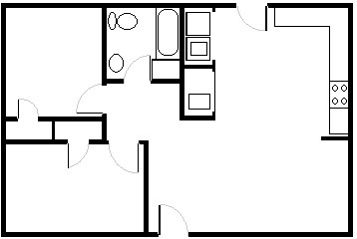

**Range**

**Sink**

**Closet Closet**

**Living Room**

**Bedroom**

**Front**



Roof

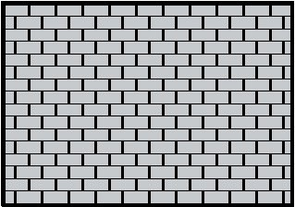

This model house is based on an actual ﬂoor plan of a Habitat for Humanity two-bedroom house in the U.S. Habitat for Humanity, together with volunteers and future home- owners builds simple, decent, aﬀordable houses like this one and sells them using aﬀordable interest free mortgages.

The average Habitat three-bedroom house mortgage monthly payment in the United States is $266. Visit [www.habitat.org](http://www.habitat.org/) to learn more about Habitat for Humanity International and to ﬁnd out how you can get involved.

***To Construct Roof:***

1. Cut roof oﬀ of this sheet of paper3. Trim extra cereal box cardboard from edges of roof
2. Glue two side pieces from cereal box on to back of roof4. Tape roof to tops of walls

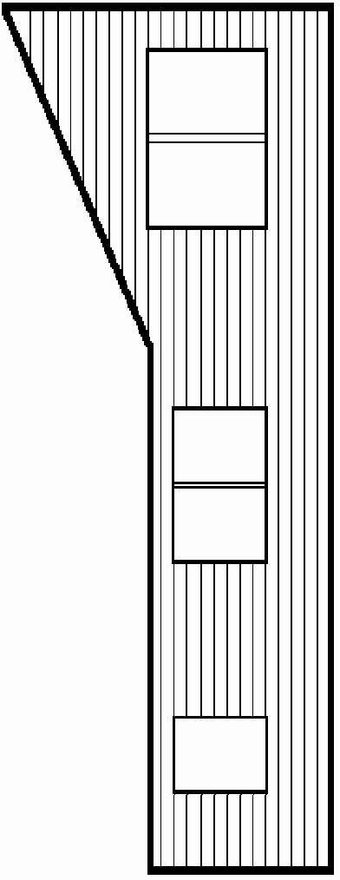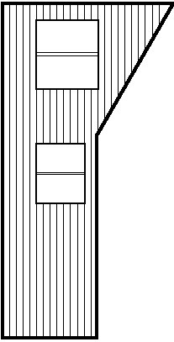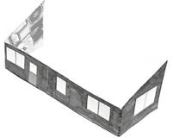

**Wall 1**

**Wall 2**

**Fold Fold**

Walls

***Instructions:***

* 1. Cut out wall 1 & 2
  2. Glue wall 1 & 2 to a large piece of cereal box cardboard – glue to the side with not writing
  3. Color walls (optional)
  4. Fold wall 1 & 2 on “fold” line at 90 degree angles

– fold so that the cardboard sides face each other

* 1. Glue wall 1 onto wall 2 on the “glue here” square.
  2. See picture for ﬁnished wall

**Cut**

**Glue Here**

|  |  |  |
| --- | --- | --- |
|  | | |
| Basic Furniture | | |
| **Couch** | | **Kitchen Table** |
| **Kitchen Chair** | **Bed** |
| **Coﬀee Table** |
| ***Instructions:***   1. Cut around outer edge of furniture shapes. 2. Fold on the dotted lines. 3. Tap sides of furniture together with scotch tape. 4. The pictures are examples of the assembled furniture. |
|  | |  |
| **P1** | | |

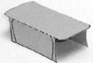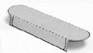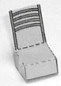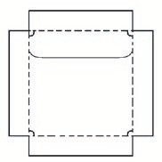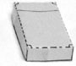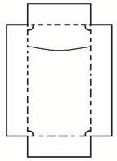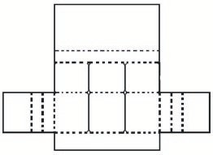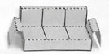

Extra Furniture

**Kitchen Chair T.V.**

**Dresser**

**Nightstand**

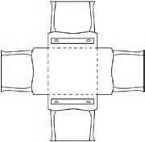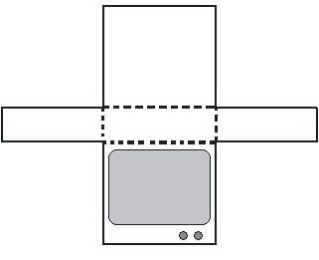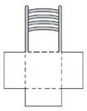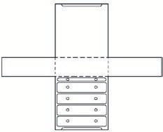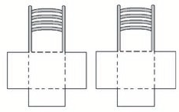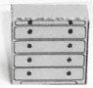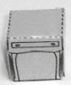

**P2**